Supplementary material

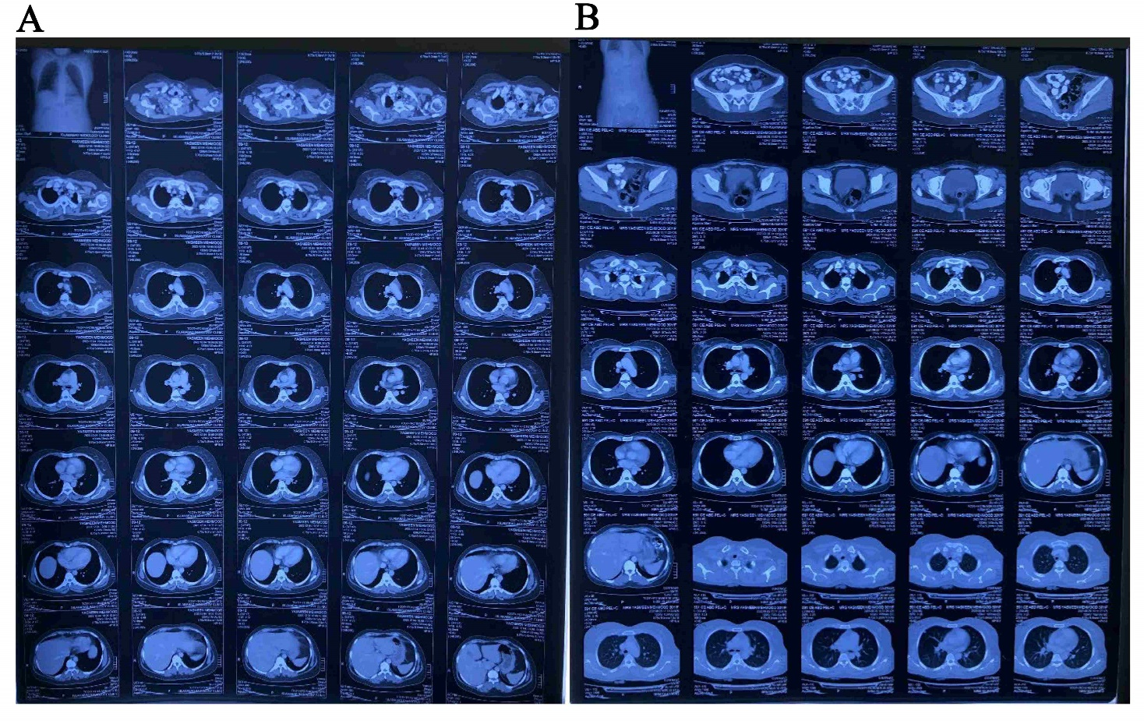
Supplementary Fig. 1. CECT chest/abdomen and pelvis showed suspicion of lung metastases. (A) Contrast Enhanced CT Scan Chest/Abdomen showed suspicion of lung metastases. (B) Contrast enhanced CT Scan Pelvis.

