Supplementary material

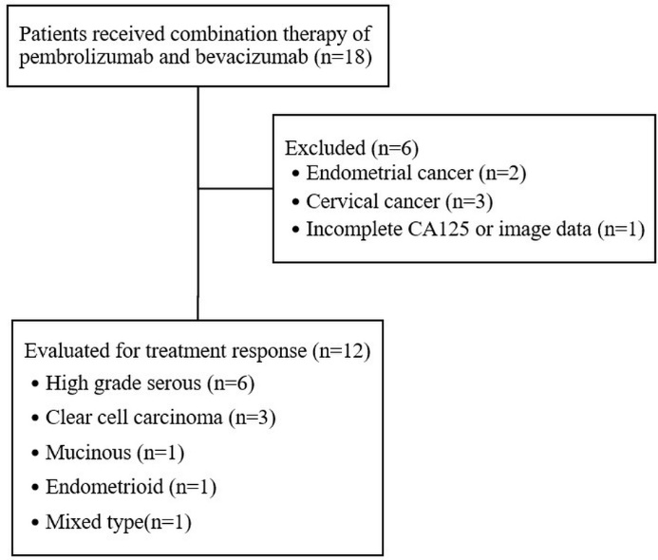
Supplementary Fig. 1. Study flow chart.

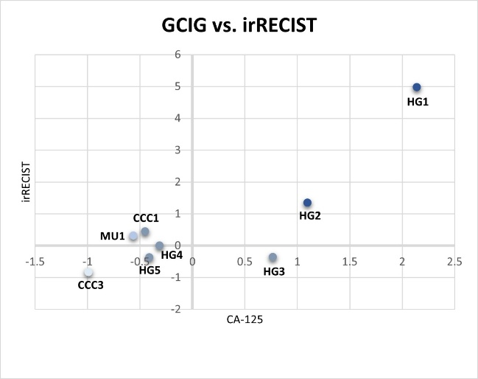
Supplementary Fig. 2. Dual assessment of GCIG and irRECIST. Abbreviations: CCC: clear cell carcinoma; HG: high-grade serous carcinoma; MU: mucinous carcinoma; irRECIST: immune-related Response Evaluation Criteria in Solid Tumors; CA-125: cancer antigen 125.

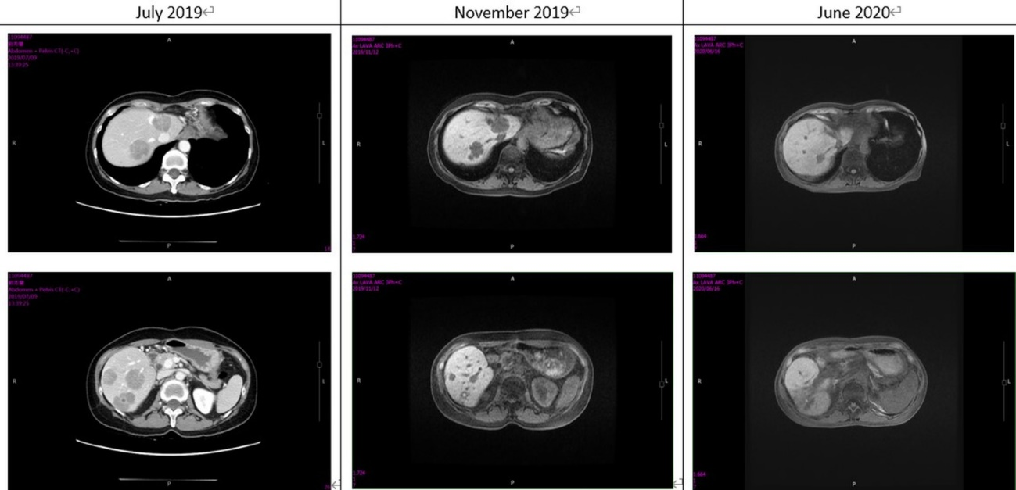
Supplementary Fig. 3. Tumor regression under combined therapy with radiotherapy. This figure illustrates the tumor response in a patient with recurrent mixed epithelial carcinoma of the ovary (FIGO stage IIIB) who initially received pembrolizumab and bevacizumab. After three months, imaging revealed tumor progression, prompting the addition of radiotherapy to target liver metastases. Subsequently, an abscopal effect was observed, leading to tumor regression on follow-up imaging.

Supplementary Table 1. Response data according to histological type and PD-L1 status.
Histological Type | PD-L1 | GCIG | irRECIST
CCC1 | Positive (1%) | Nonresponse | irPD
CCC2 |  | Response
CCC3 | Negative | Response and NR | irPR
HG1 | Negative | Progression | irPD
HG2 | Negative | Progression | irPD
HG3 | Positive (5%) | Nonresponse | irSD
HG4 | Positive (1%) | Nonresponse | irSD
HG5 | Negative | Nonresponse | irSD
PSPC1 |  | Progression
MU1 | Negative | Response | irSD
EN1 | Negative | Response
MIX1 |  |  | irPR
Abbreviations: CCC: clear cell carcinoma; HG: high-grade serous carcinoma; PSPC: peritoneal serous papillary carcinoma; MU: mucinous carcinoma; EN: endometrioid carcinoma; MIX: mixed epithelial carcinoma; NR: normalized; irPR: irRECIST partial response; irSD: irRECIST stable disease; irPD: irRECIST progressive disease.

Supplementary Table 2. Drug-related adverse events.
Drug-related Adverse Events | Grade 1–2 | Grade 3–4
Fatigue | 0 | 0
Nausea | 2 | 0
Diarrhea | 2 | 0
Hypertension | 0 | 0
Renal insufficiency | 0 | 1
Proteinuria | 1 | 0
Rash | 2 | 0
Pruritis | 2 | 0
Alopecia | 1 | 0
Peripheral neuropathy | 1 | 0
Leukocytopenia | 0 | 0
Lymphocyte count decreased | 0 | 3
Thrombocytopenia | 1 | 0
Hypothyroidism | 0 | 0
AST or ALT elevation | 0 | 0
Arthralgia | 1 | 0
Dyspnea | 3 | 0
GI bleeding | 0 | 1
Total | 5 (41.7%) | 4 (33.3%)
Abbreviations: AST: aspartate aminotransferase; ALT: alanine aminotransferase; GI: gastrointestinal.

