Supplementary material

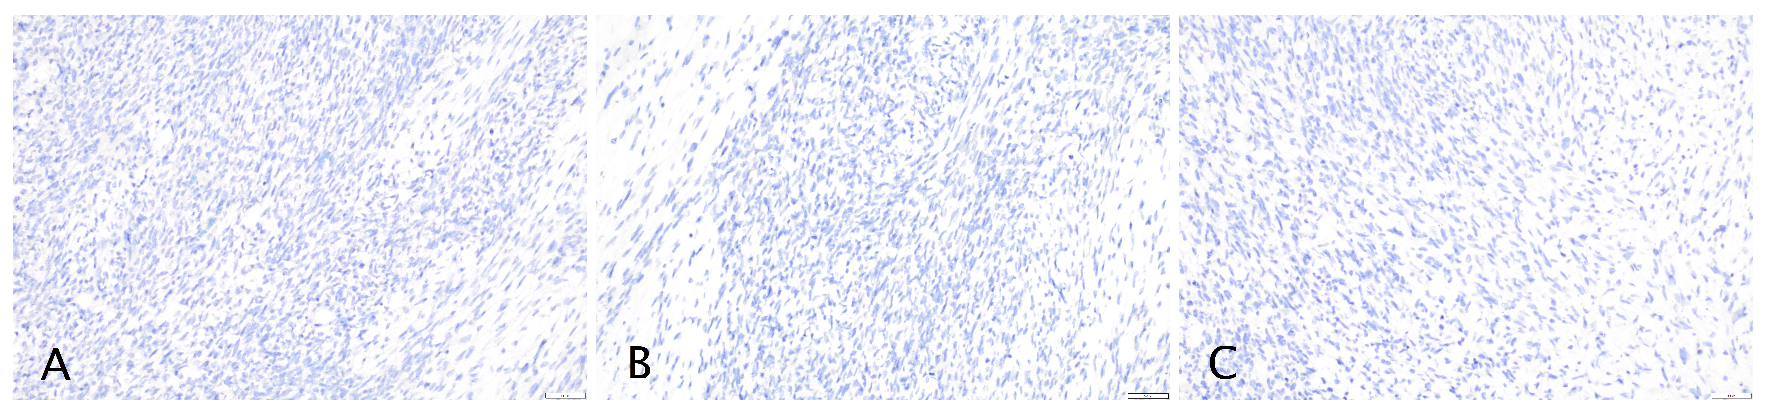
Supplementary Fig. 1. Negative Immunohistochemistry. (A) Negative calretinin staining of tumour tissue, ×100 magnification. (B) Negative inhibin staining of tumour tissue, ×100 magnification. (C) Negative SF-1 staining of tumour tissue, ×100 magnification.

