Supplementary material

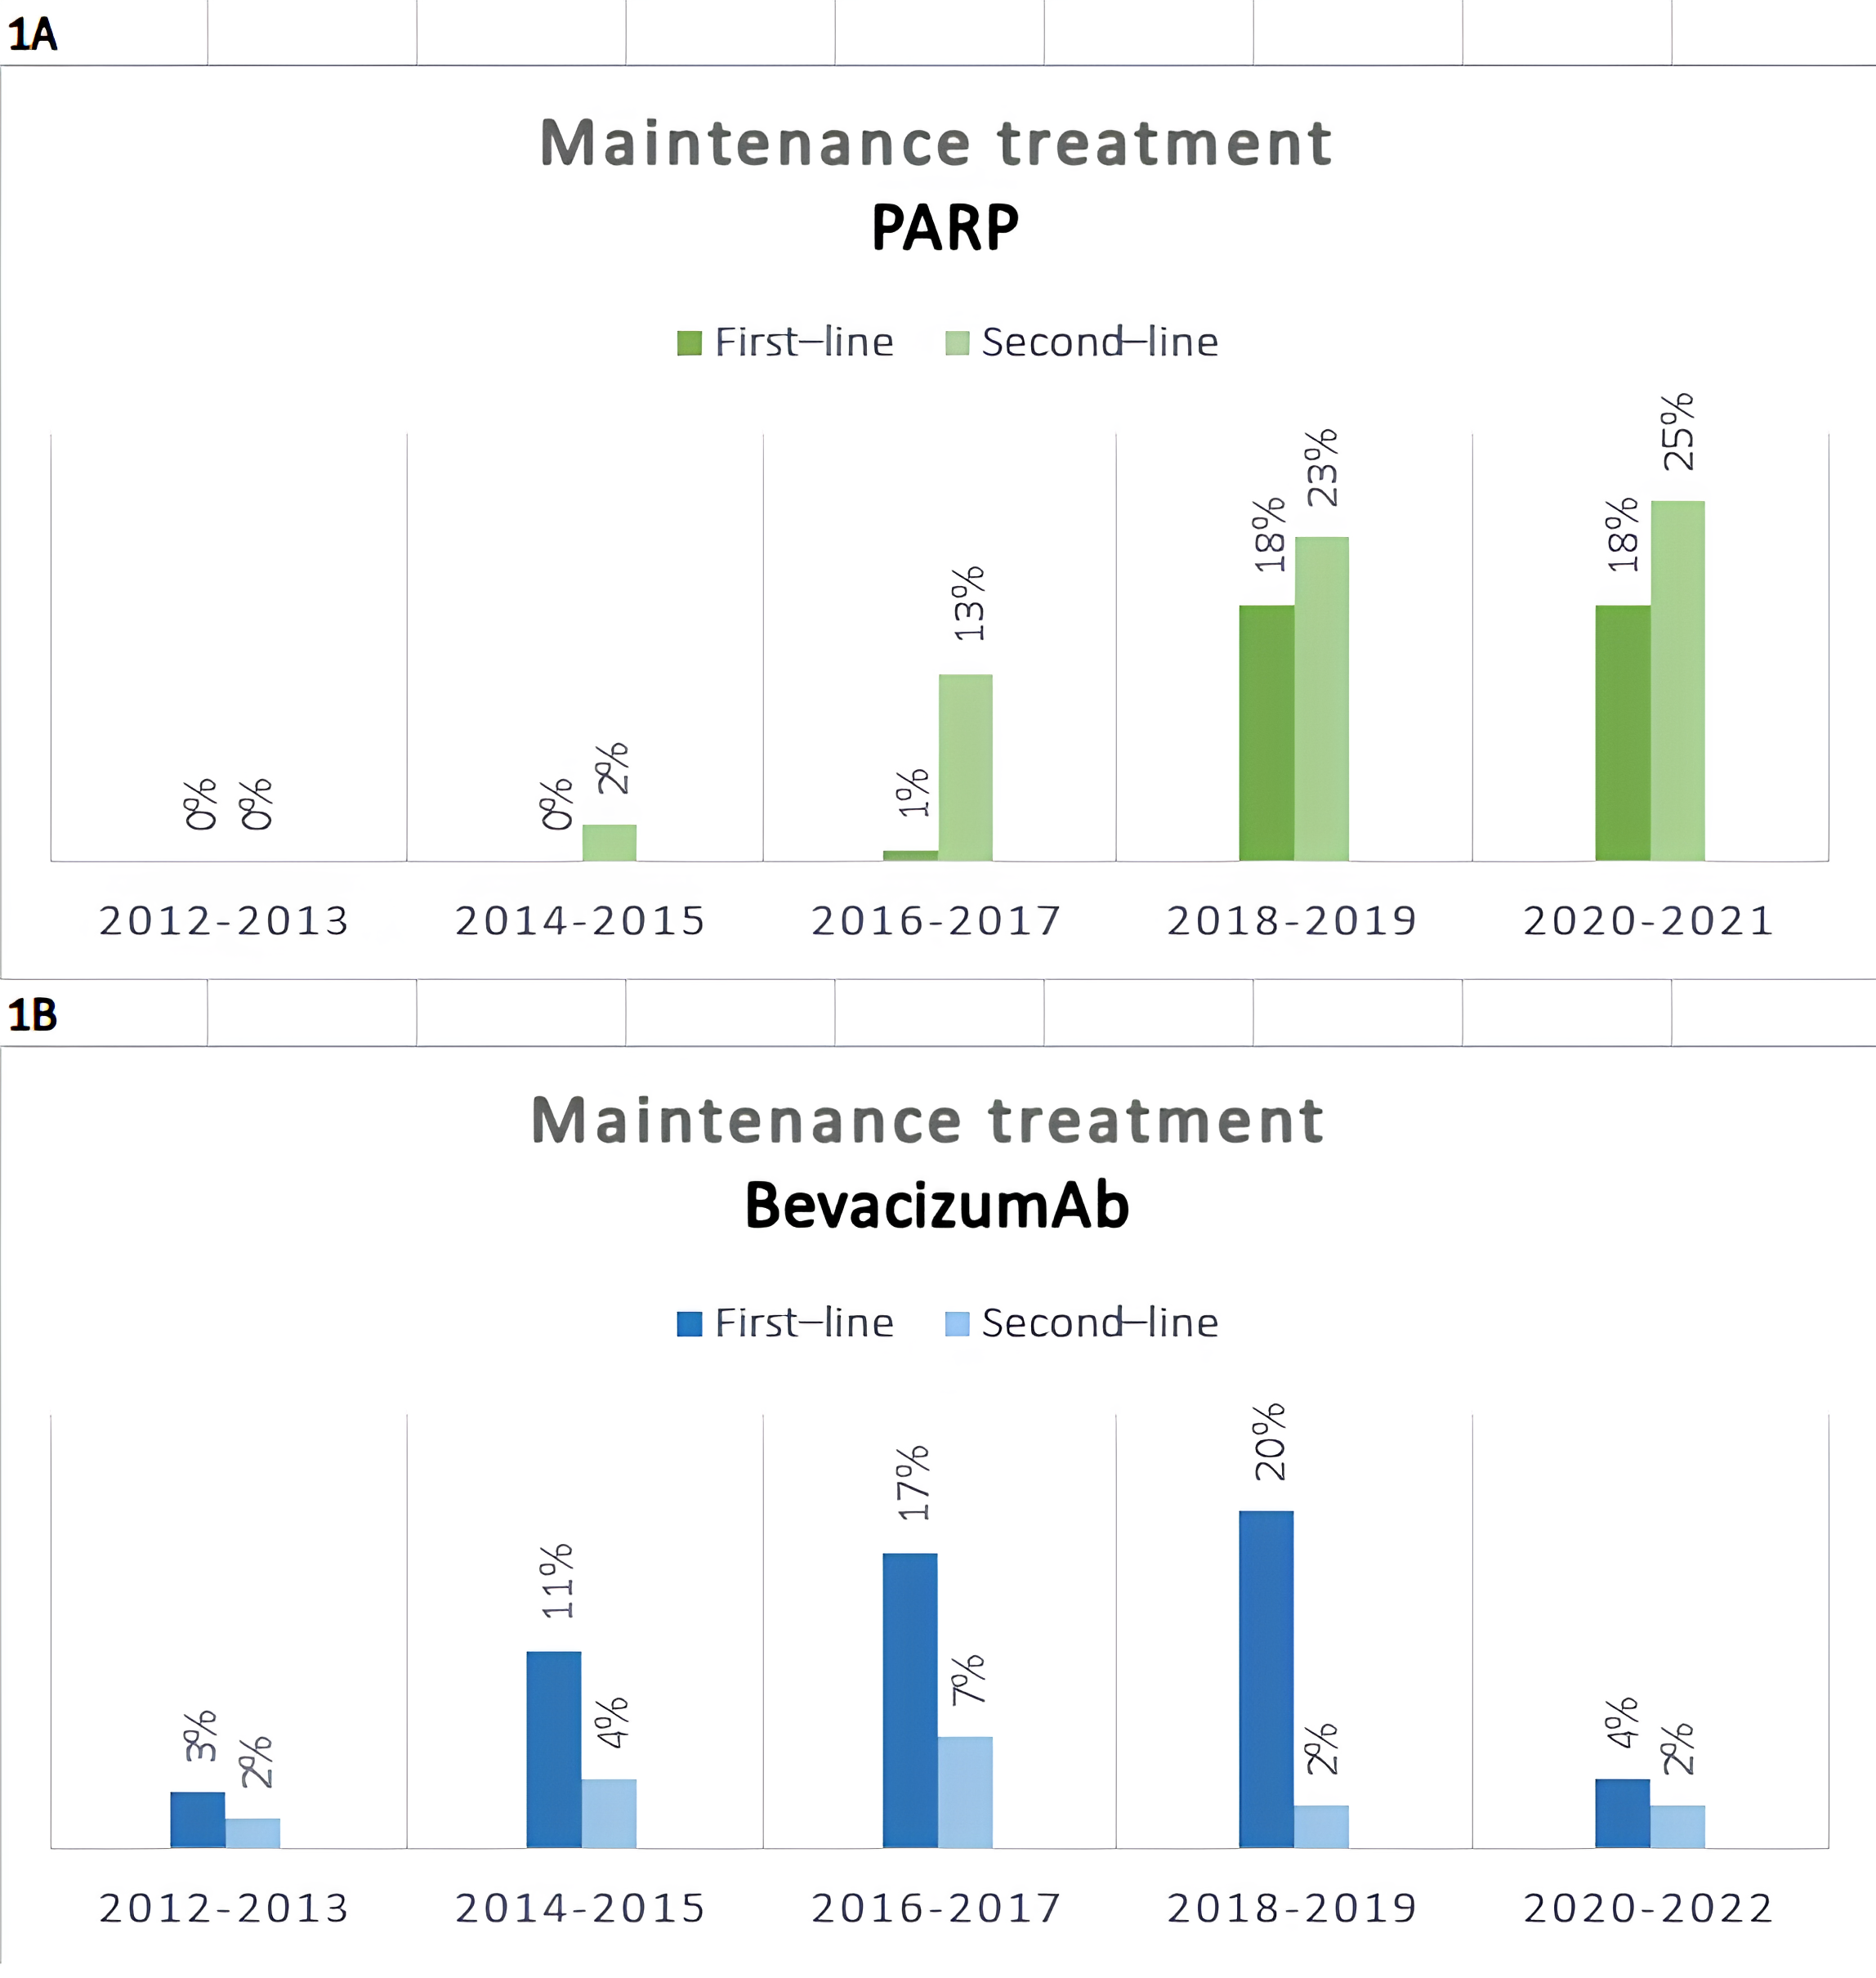
Supplementary Fig. 1. Administration rates of PARP inhibitors and bevacizumab as maintenance therapy through the years. (A) PARP (B) BevacizumAb. PARP: Poly (ADP-ribose) polymerase.

Supplementary Fig. 2. Progression-free survival (PFS) in patients who received maintenance treatment after first-line therapy compared to patients who did not receive any maintenance treatment.

Supplementary Fig. 3. Overall survival (OS) in patients who received maintenance treatment after first-line therapy compared to patients who did not receive any maintenance treatment.

Supplementary Fig. 4. Progression-free survival (PFS) in patients with and without germline BRCA1/2 mutations. MUT: Mutation; WT: Wild Type; BRCA1/2: Breast Cancer gene 1, Breast Cancer gene 2.

Supplementary Fig. 5. Overall survival (OS) in patients with and without germline BRCA1/2 mutations. MUT: Mutation; WT: Wild Type; BRCA1/2: Breast Cancer gene 1, Breast Cancer gene 2.

Supplementary Table 1. Details on mutations identified with genetic and/or tumor molecular testing.
BRCA1/2 status
Germline | Somatic | N (%)
Mutant | Mutant | 94 (53.7%)
Mutant | Wild type | 0 (0.0%)
Wild type | Wild type | 77 (44.0%)
Wild type | Mutant | 4 (2.3%)
BRCA1/2: Breast Cancer gene 1, Breast Cancer gene 2.

Supplementary Table 2. PFS and OS in 1st line and 2nd line maintenance treatment.
 |  |  |  | N | Events (%) | Median with 95% CI | Long rank test | HR with 95% CI | Sig. | aHR with 95% CI^ | Sig.
First line treatment
 | PFS1 | Maintenance treatment | Yes | 119* | 85 (71.4) | 28.2 (22.8, 35.4) | p < 0.001 | 0.53 (0.38, 0.74) | p < 0.001 | 0.44 (0.30, 0.67) | p < 0.001
 | PFS1 | Maintenance treatment | No | 64 | 61 (95.3) | 17.1 (15.1, 20.5) | p < 0.001 | Ref. |  | Ref.
 | PFS1 | Maintenance treatment (N = 171) | Olaparib | 42 | 15 (35.7) | NE | p < 0.001 | 0.25 (0.14, 0.44) | p < 0.001 | 0.16 (0.08, 0.33) | p < 0.001
 | PFS1 | Maintenance treatment (N = 171) | Bevacizumab | 65 | 62 (95.4) | 26.3 (21.5, 31.5) | p < 0.001 | 0.67 (0.47, 0.96) | p = 0.030 | 0.61 (0.40, 0.94) | p = 0.024
 | PFS1 | Maintenance treatment (N = 171) | No | 64 | 61 (95.3) | 17.1 (15.1, 20.5) | p < 0.001 | Ref. |  | Ref.
 | OS | Maintenance treatment | Yes | 119* | 48 (40.3) | 91.5 (71.8, 98.1) | p = 0.590 | 0.89 (0.58, 1.36) | p = 0.593 | 1.02 (0.62, 1.68) | p = 0.932
 | OS | Maintenance treatment | No | 64 | 43 (67.2) | 72.8 (59.7, 86.1) | p = 0.590 | Ref. |  | Ref.
 | OS | Maintenance treatment (N = 171) | Olaparib | 42 | 11 (26.2) | NE | p = 0.110 | 1.61 (0.78–3.32) | p = 0.194 | 1.28 (0.53, 3.13) | p = 0.581
 | OS | Maintenance treatment (N = 171) | Bevacizumab | 65 | 33 (50.8) | 91.8 (79.8, NE) | p = 0.110 | 0.76 (0.47–1.20) | p = 0.238 | 0.95 (0.56, 1.61) | p = 0.838
 | OS | Maintenance treatment (N = 171) | No | 64 | 43 (67.2) | 72.8 (59.7, 86.1) | p = 0.110 | Ref. |  | Ref.
Second line treatment
 | PFS2 | Maintenance treatment | Yes | 96# | 68 (70.8) | 23.0 (19.4, 25.7) | p < 0.001 | 0.37 (0.25, 0.55) | p < 0.001 | 0.44 (0.28, 0.69) | p < 0.001
 | PFS2 | Maintenance treatment | No | 45 | 41 (91.1) | 12.1 (8.4, 15.9) | p < 0.001 | Ref. |  | Ref.
 | PFS2 | Maintenance treatment | Olaparib | 75 | 48 (64.0) | 25.4 (19.5, 34.0) | p < 0.001 | 0.31 (0.20, 0.47) | p < 0.001 | 0.36 (0.22, 0.59) | p < 0.001
 | PFS2 | Maintenance treatment | Bevacizumab | 20 | 19 (95.0) | 19.5 (17.0, 24.7) | p < 0.001 | 0.66 (0.38, 1.15) | p = 0.144 | 0.76 (0.40, 1.44) | p = 0.399
 | PFS2 | Maintenance treatment | No | 45 | 41 (91.1) | 12.1 (8.4, 15.9) | p < 0.001 | Ref. |  | Ref.
HR: Hazard Ratio; aHR: adjusted Hazard Ratio; NE: non-estimable; Sig.: Significance level; Ref.: Reference; OS: Overall Survival; PFS: Progression free survival; CI: Confidence Interval.
*Included: Olaparib + Bevacizumab = 1, Niraparib = 3, other (nivolumab, rucaparib, trabectedin) = 8.
#: Included: Niraparib = 1.
^: Adjusted with age, germline BRCA1/2, family history of cancer and FIGO stage.

Supplementary Table 3. Progression-free survival in older patients (>65 years old).
Women > 65 |  |  |  | N | Events (%) | Median with 95% CI | Long rank test | HR with 95% CI | Sig. | aHR with 95% CI^ | Sig.
First line treatment
 | PFS1 | Maintenance treatment | Olaparib | 12 | 4 (30.0) | NE | p = 0.001 | 0.33 (0.11, 1.04) | p = 0.058 | 0.15 (0.03, 0.81) | p = 0.028
 | PFS1 | Maintenance treatment | Bevacizumab | 14 | 14 (100) | 27.8 (14.2, 64.3) | p = 0.001 | Ref. |  | Ref.
Second line treatment
 | PFS2 | Maintenance treatment | Olaparib | 19 | 14 (73.7) | 19.5 (18.0, NE) | p = 0.460 | 0.70 (0.26, 1.84) | p = 0.469 | 0.39 (0.07, 2.03) | p = 0.262
 | PFS2 | Maintenance treatment | Bevacizumab | 7 | 6 (85.7) | 21.6 (12.9, NE) | p = 0.460 | Ref. |  | Ref.
HR: Hazard Ratio; aHR: adjusted Hazard Ratio; NE: non-estimable. Sig.: Significance level; CI: Confidence Interval; PFS: Progression free survival.
^Adjusted with germline BRCA1/2, family history of cancer and FIGO stage.

Supplementary Table 4. Response rates.
Characteristic |  | Olaparib | Bevacizumab | No maintenance treatment | Sig.
Clinical response after platinum-based chemotherapy as 1st line, N (%) |  | (N = 39) | (N = 55) | (N = 54)
 | Complete response | 27 (69.2%) | 28 (50.9%) | 35 (64.8%) | 0.328
 | Partial response | 6 (15.4%) | 15 (27.3%) | 8 (14.8%) | 0.328
 | Stable disease | 6 (15.4%) | 12 (21.8%) | 11 20.4%) | 0.328
 | Progression disease | 0 (0.0%) | 0 (0.0%) | 0 (0.0%) | 0.328
Clinical response after platinum-based chemotherapy as 2nd line, N (%) |  | (N = 63) | (N = 20) | (N = 27)
 | Complete response | 23 (36.5%) | 2 (10.0%) | 7 (25.9%) | 0.047
 | Partial response | 25 (39.7%) | 13 (65.0%) | 11 (40.8%) | 0.047
 | Stable disease | 15 (23.8%) | 4 (20.0%) | 6 (22.2%) | 0.047
 | Progression disease | 0 (0.0%) | 1 (5.0%) | 3 (11.1%) | 0.047
Sig.: Significance level.

Supplementary Table 5. Adverse events.
 |  | Olaparib (Ν = 117) |  |  |  |  | Bevacizumab (Ν = 79)
Hematological toxicity
 | Adverse event | All grades | Grade 1 | Grade 2 | Grade 3 | Grade 4 | All grades | Grade 1 | Grade 2 | Grade 3 | Grade 4
 | Anemia | 48 (41.0%) | 29 (24.8%) | 7 (6.0%) | 12 (10.3%) | 0 (0.0%) | 25 (31.6%) | 19 (24.1%) | 6 (7.6%) | 0 (0.0%) | 0 (0.0%)
 | Leukopenia | 26 (22.2%) | 19 (16.2%) | 4 (3.4%) | 3 (2.6%) | 0 (0.0%) | 15 (19.0%) | 10 (12.7%) | 4 (5.1%) | 1 (1.3%) | 0 (0.0%)
 | Neutropenia | 1 (0.9%) | 0 (0.0%) | 1 (0.9%) | 0 (0.0%) | 0 (0.0%) | 0 (0.0%) | 0 (0.0%) | 0 (0.0%) | 0 (0.0%) | 0 (0.0%)
 | Thrombocytopenia | 16 (13.7%) | 11 (9.4%) | 2 (1.7%) | 2 (1.7%) | 1 (0.9%) | 10 (12.7%) | 9 (11.4%) | 0 (0.0%) | 1 (1.3%) | 0 (0.0%)
Non-hematological toxicity
 | Fatigue | 20 (17.1%) | 15 (12.8%) | 4 (3.4%) | 1 (0.9%) | 0 (0.0%) | 9 (11.4%) | 8 (10.1%) | 1 (1.3%) | 0 (0.0%) | 0 (0.0%)
 | Nausea | 6 (5.1%) | 6 (5.1%) | 0 (0.0%) | 0 (0.0%) | 0 (0.0%) | 5 (6.3%) | 3 (3.8%) | 2 (2.5%) | 0 (0.0%) | 0 (0.0%)
 | Vomiting | 4 (3.4%) | 4 (3.4%) | 0 (0.0%) | 0 (0.0%) | 0 (0.0%) | 1 (1.3%) | 1 (1.3%) | 0 (0.0%) | 0 (0.0%) | 0 (0.0%)
 | Arthralgia | 1 (0.9%) | 1 (0.9%) | 0 (0.0%) | 0 (0.0%) | 0 (0.0%) | 6 (7.6%) | 5 (6.3%) | 1 (1.3%) | 0 (0.0%) | 0 (0.0%)
 | Atrial fibrillation | 1 (0.9%) | 1 (0.9%) | 0 (0.0%) | 0 (0.0%) | 0 (0.0%) | 0 (0.0%) | 0 (0.0%) | 0 (0.0%) | 0 (0.0%) | 0 (0.0%)
 | Blurred vision | 1 (0.9%) | 1 (0.9%) | 0 (0.0%) | 0 (0.0%) | 0 (0.0%) | 0 (0.0%) | 0 (0.0%) | 0 (0.0%) | 0 (0.0%) | 0 (0.0%)
 | Bowel obstruction | 1 (0.9%) | 1 (0.9%) | 0 (0.0%) | 0 (0.0%) | 0 (0.0%) | 0 (0.0%) | 0 (0.0%) | 0 (0.0%) | 0 (0.0%) | 0 (0.0%)
 | Dysphagia | 1 (0.9%) | 1 (0.9%) | 0 (0.0%) | 0 (0.0%) | 0 (0.0%) | 0 (0.0%) | 0 (0.0%) | 0 (0.0%) | 0 (0.0%) | 0 (0.0%)
 | Edema | 1 (0.9%) | 1 (0.9%) | 0 (0.0%) | 0 (0.0%) | 0 (0.0%) | 0 (0.0%) | 0 (0.0%) | 0 (0.0%) | 0 (0.0%) | 0 (0.0%)
 | Erythema | 0 (0.0%) | 0 (0.0%) | 0 (0.0%) | 0 (0.0%) | 0 (0.0%) | 1 (1.3%) | 1 (1.3%) | 0 (0.0%) | 0 (0.0%) | 0 (0.0%)
 | Hypertension | 0 (0.0%) | 0 (0.0%) | 0 (0.0%) | 0 (0.0%) | 0 (0.0%) | 1 (1.3%) | 1 (1.3%) | 0 (0.0%) | 0 (0.0%) | 0 (0.0%)
 | Neuropathy | 0 (0.0%) | 0 (0.0%) | 0 (0.0%) | 0 (0.0%) | 0 (0.0%) | 1 (1.3%) | 0 (0.0%) | 1 (1.3%) | 0 (0.0%) | 0 (0.0%)
 | Diarrhea | 0 (0.0%) | 0 (0.0%) | 0 (0.0%) | 0 (0.0%) | 0 (0.0%) | 1 (1.3%) | 1 (1.3%) | 0 (0.0%) | 0 (0.0%) | 0 (0.0%)
 | Hypertension | 0 (0.0%) | 0 (0.0%) | 0 (0.0%) | 0 (0.0%) | 0 (0.0%) | 0 (0.0%) | 0 (0.0%) | 0 (0.0%) | 0 (0.0%) | 0 (0.0%)
 | Thrombosis | 0 (0.0%) | 0 (0.0%) | 0 (0.0%) | 0 (0.0%) | 0 (0.0%) | 0 (0.0%) | 0 (0.0%) | 0 (0.0%) | 0 (0.0%) | 0 (0.0%)
 | Perforation/fistula | 0 (0.0%) | 0 (0.0%) | 0 (0.0%) | 0 (0.0%) | 0 (0.0%) | 0 (0.0%) | 0 (0.0%) | 0 (0.0%) | 0 (0.0%) | 0 (0.0%)
 | Proteinuria | 0 (0.0%) | 0 (0.0%) | 0 (0.0%) | 0 (0.0%) | 0 (0.0%) | 0 (0.0%) | 0 (0.0%) | 0 (0.0%) | 0 (0.0%) | 0 (0.0%)
Abbreviations: N: number.

