Supplementary material

Supplementary Table 1. Treatment details.
Characteristics |  | Complete Response | Temporary/No response | Total
 |  | n (%) | n (%) | n (%)
Total |  | 16 (61.5) | 10 (38.5) | 26 (100.0)
Previous hemostatic treatments
 | Bladder irrigation | 2 (12.5) | 0 (0.0) | 2 (7.7)
 | Formalin to the bladder | 1 (6.2) | 0 (0.0) | 1 (3.8)
 | Hyperbaric therapy | 1 (6.2) | 0 (0.0) | 1 (3.8)
 | Vaginal tampon | 12 (75.0) | 6 (60.0) | 18 (69.2)
 | Tranexamic acid | 13 (81.2) | 7 (70.0) | 20 (76.9)
 | Hemostatic radiotherapy | 1 (6.2) | 1 (10.0) | 2 (7.7)
 | Hemostatic surgery | 1 (6.2) | 0 (0.0) | 1 (3.8)
 | No treatment | 0 (0.0) | 1 (10.0) | 1 (3.8)
Precise clinical indication for TAE
 | Metrorrhagia | 10 (62.5) | 5 (50.0) | 15 (57.7)
 | Metrorrhagia and deep vein thrombosis | 2 (12.5) | 0 (0.0) | 2 (7.7)
 | Radiation cystitis | 1 (6.2) | 1 (10.0) | 2 (7.7)
 | Radiation retitis | 0 (0.0) | 2 (20.0) | 2 (7.7)
 | Radiation retitis and cystitis | 2 (12.5) | 1 (10.0) | 3 (11.5)
CIRSE complications scale
 | 0 | 15 (93.8) | 9 (90.0) | 24 (92.3)
 | 1 | 1 (6.2) | 1 (10.0) | 2 (7.7)
 | 3 | 0 (0.0) | 0 (0.0) | 0 (0.0)
 | 4 | 0 (0.0) | 0 (0.0) | (0.0)
Embolized artery
 | Right uterine | 9 (56.2) | 6 (60.0) | 15 (57.7)
 | Left uterine | 12 (75.0) | 5 (50.0) | 17 (65.4)
 | Right superior vesical | 3 (18.8) | 2 (20.0) | 5 (19.2)
 | Left superior vesical | 1 (6.2) | 0 (0.0) | 1 (3.8)
 | Right middle rectal | 1 (6.2) | 0 (0.0) | 1 (3.8)
 | Left middle rectal | 1 (6.2) | 0 (0.0) | 1 (3.8)
 | Right internal iliac | 1 (6.2) | 2 (20.0) | 3 (11.5)
 | Left internal iliac | 2 (12.5) | 1 (10.0) | 3 (11.5)
 | Other branches of the internal iliac | 2 (12.5) | 1 (10.0) | 3 (11.5)
Embolic agent
 | Gel Foam | 10 (62.5) | 5 (50.0) | 15 (57.7)
 | PVA particles | 11 (68.7) | 8 (80.0) | 19 (73.1)
Data are presented as n (%). CIRSE: Cardiovascular and Interventional Radiological Society of Europe; TAE: Transarterial embolization; PVA: Polyvinyl alcohol particles.

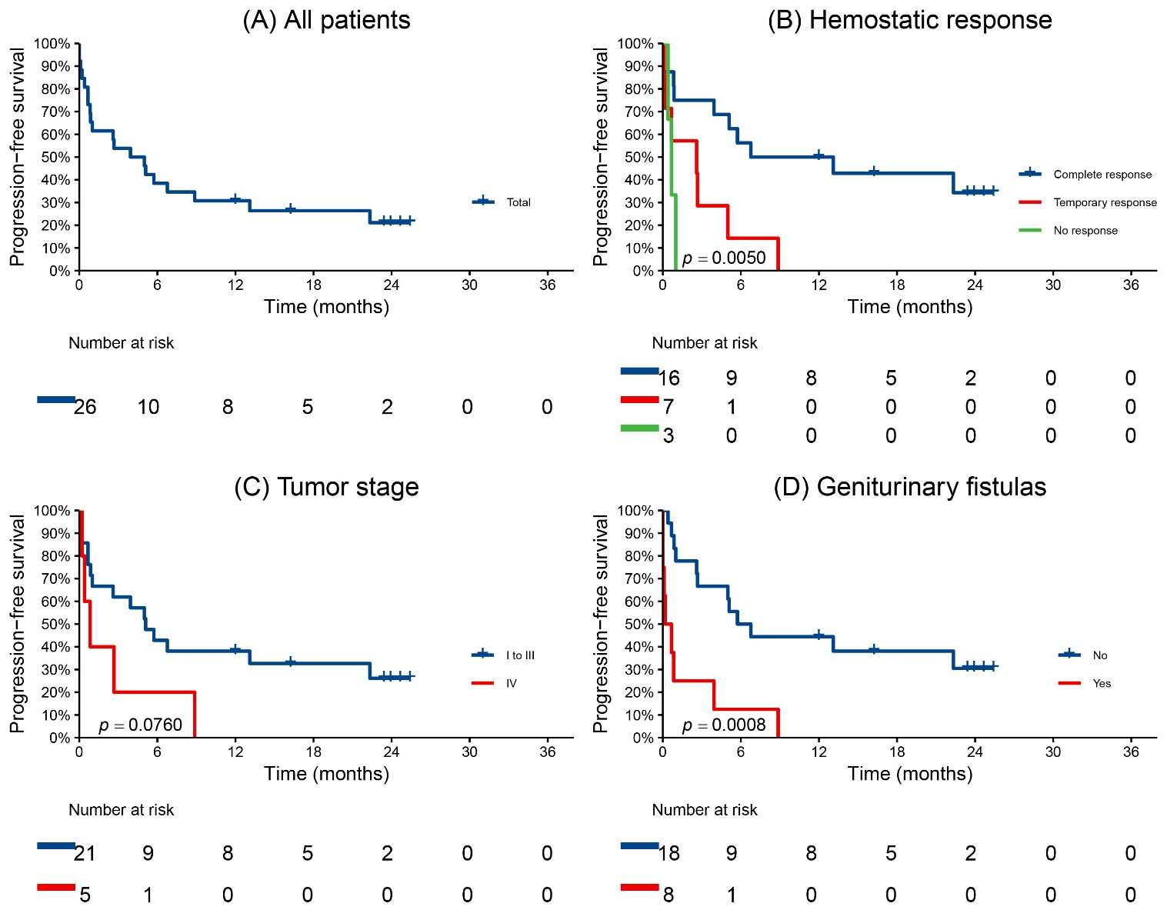
Supplementary Fig. 1. Progression-free survival after pelvic transarterial embolization (TAE). Kaplan-Meier PFS of all patients surveyed (A), hemostatic response (B), tumoral stage (C) and genitourinary fistulas (D). The median PFS after pelvic transarterial embolization (TAE) was 4.5 months (95% CI: 0.9–22.3) and 20 disease progression or deaths (events) occurred among the 26 participants during the 23.9-month follow-up. Patients with temporary and no response to TAE, stage IV and with fistulas had zero 12-month PFS rate.

Supplementary Table 2. Univariable hazard ratios by Cox regression analysis for the progression-free survival predictors studied.
Progression-free survival predictor | n | Univariable
Progression-free survival predictor | n | HR | 95% CI | p-value
FIGO stage IV | 5 | 2.47 | (0.87–7.03) | 0.091
TempR/NR | 10 | 4.20 | (1.57–11.24) | 0.004*
Presence of genitourinary fistulas | 8 | 4.55 | (1.75–11.85) | 0.002*
HR: Hazard ratio; CI: confidence interval; FIGO: The International Federation of Gynecology and Obstetrics; TempR/NR: temporary or no response to pelvic transarterial embolization. *Statistically significant p-value.

