Supplementary material

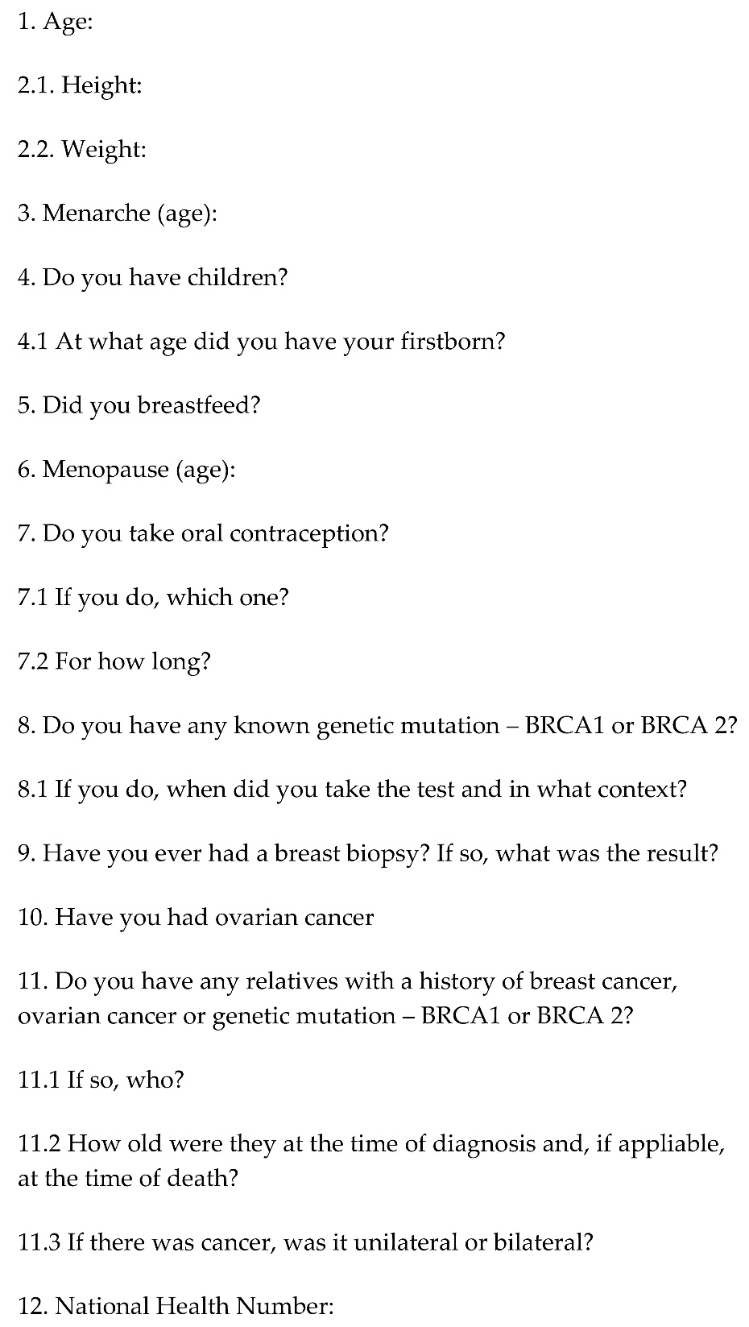
Supplementary Fig. 1. Questionnaire template. BRCA: Breast cancer gene.

