Original Research
Utility of Intraoperative Frozen Section of the Inguinofemoral Sentinel Lymph Node in Vulvar Cancer: A Retrospective Cohort

Naixin Zhang^{1,*}, Joann Gold¹, Ben Wilson², Catherine Coffman¹, Mark Reed², Adam C. ElNaggar^{2,*}

¹Department of Obstetrics and Gynecology, University of Tennessee Health Science Center, Memphis, TN, 38103, USA
²Division of Gynecologic Oncology, West Cancer Center and Research Institute, Memphis, TN, 38138, USA

*Correspondence: nzhang8@uthsc.edu (Naixin Zhang); acelnaggar@gmail.com (Adam C. ElNaggar)

Submitted: 13 January 2022
Accepted: 24 February 2022

Copyright: © 2022 The Author(s). Published by MRE Press.
This is an open access article under the CC BY 4.0 license (http://creativecommons.org/licenses/by/4.0/).

How to cite this article:
Naixin Zhang, Joann Gold, Ben Wilson, Catherine Coffman, Mark Reed, Adam C. ElNaggar. Utility of Intraoperative Frozen Section of the Inguinofemoral Sentinel Lymph Node in Vulvar Cancer: A Retrospective Cohort. European Journal of Gynaecological Oncology. 2022. doi: 10.31083/j.ejgoxxxx.

Abstract
Objective: Sentinel lymph node dissection (SLND) spares most patients diagnosed with clinically early-stage vulvar cancer from undergoing complete inguinofemoral lymphadenectomy (IFLND). We sought to evaluate the intraoperative examination of frozen sentinel lymph node (SLN) sections to assess the need for IFLND. Methods: We identified patients with vulvar cancer treated at a tertiary referral center between January 2006 and December 2019 who either underwent SLND or met the eligibility criteria to receive SLND. All patients were restaged according to the International Federation of Gynaecology and Obstetrics (FIGO) 2009 guidelines. The records of each patient were reviewed for disease characteristics, follow-up status, patient demographics, SLN eligibility, and surgical and pathologic variables. Results: Of 142 eligible patients, 76 underwent SLND (53.5%) for a total of 118 groins assessed. We found no statistically significant differences in characteristics between the cohorts that received or lacked SLN examination. The SLN was detected in 90.8% (95% Confidence Interval (CI): 81.9%–96.2%) of patients. SLNs of 52 patients were sent for frozen section, and the results were used to direct further surgical intervention. The results of the frozen section pathology and the final pathology report exhibited a high degree of correlation per patient (100%) and per groin (98.7%). The 1 incorrect groin was negative on frozen but positive on final pathology and therefore no patients received an incorrect complete groin dissection. We observed no statistically significant differences in recurrence-free survival or overall survival rates between those patients who received or did not receive SLND. Conclusion: The use of intraoperative frozen section is appropriate for assessing node status at time of initial surgery. The use of this method decreases the incidence of reoperation by identifying those patients who warrant immediate IFLND.
Keywords
Vulvar; sentinel; Lymph nodes; Frozen section; Surgery

1. Introduction
Vulvar carcinomas account for 6% of gynecologic cancers. Nearly 6500 new cases of vulvar carcinoma are diagnosed in the U.S. annually [1]. Lymph node status is the single most important prognostic factor for patients with vulvar carcinoma [2, 3]. The 5-year overall survival (OS) rate of patients without nodal involvement is 91% versus 52% for patients with nodal involvement [4]. In clinically early-stage disease where the tumor size is less than four cm in diameter, approximately one third of patients will have involvement of the lymph nodes [5, 6].
Determination of lymph node status is typically accomplished via bilateral or unilateral inguinofemoral lymphadenectomy (IFLND). IFLND is associated with high rates of wound complications including lymphedema (28%), lymphocyst formation (40%), infection (39%), and wound breakdown (17%) [6–9]. Therefore, the selection of patients eligible for unilateral and/or sentinel lymph node dissection (SLND) instead of IFLND represents an important step in reducing the morbidity associated with complete bilateral IFLND [6, 10–12]. SLND is an accurate means of assessing lymph node status in vulvar cancer [13]. SLND is associated with decreased morbidity and rates of detection of lymph node metastases that are equivalent to those of complete bilateral IFLND without an increased risk of groin recurrence or compromising disease specific survival. Isolated groin recurrences following a negative SLND are less than 3% [14, 15].
Patients with a sentinel lymph node (SLN) that is enlarged >2 mm (positive for metastasis) or that possesses extracapsular extension will require a complete IFLND with subsequent radiation-based therapy. It’s importance for patient prognosis was demonstrated in GROINSS-V-II study [16]. In 162 patients with macrometastases (>2 mm) and <4 cm primary tumors, radiation treatment in the absence of IFLND resulted in a 2-year recurrence rate of 25.0% versus 8.2% in the presence of IFLND (p = 0.012) [16]. Unfortunately, complete IFLND may require a second operation if its need is only discovered subsequent to the first surgery. The aim of this study is to examine the utility of examining SLN frozen sections during the initial surgery to identify positive SLNs in patients who can subjected to complete IFLND immediately, at the time of initial surgery.

2. Materials and Methods

2.1 Inclusion and Exclusion Criteria
We performed a retrospective chart review of all patients treated for vulvar cancer at the West Cancer Center and Research Institute, Division of Gynecologic Oncology in Memphis, TN from January 2006 to December 2019. The project was initiated after exempt review and approval of the protocol under U.S. regulation 45CFR46.101(b)(4) by the University of Tennessee Health Science Center (UTHSC) Institutional Review Board (IRB). All STROBE guidelines were followed.
Patients who either received or were eligible for SLND met the inclusion criteria for the study. Patients were excluded if they had advanced and/or metastatic disease or were not eligible for SLND. Surgeon preference dictated lymph node approach. Eligibility for SLND on patients receiving IFLND was determined by preoperative exam and imaging. Eligibility for SLND required a diagnosis of vulvar cancer, the absence of clinically or radiologically suspicious lymph nodes, a depth of tumor invasion greater than one mm, tumor size less than four cm when measured edge-to-edge on the longest axis, and no prior history of treatment for vulvar carcinoma, including chemotherapy, pelvic or inguinal radiotherapy, and prior vulvar surgery (aside from excisional biopsy). All patients were restaged to International Federation of Gynaecology and Obstetrics (FIGO) 2009 staging guidelines [17].

2.2 Sentinel Node Acquisition
Radiocolloid was utilized for the detection of the SLN. One to six hours preoperatively, 0.5 to 1.0 mL of Technetium-99 microsulfur colloid was injected intradermally in each quadrant around the tumor to identify afferent lymphatic channels. Intraoperatively, a handheld gamma counter in a sterile sleeve was passed transcutaneously over the tissue to identify lymph nodes that emit the tracer. A radioactive lymph node was considered sentinel if its radioactivity was at least 2 times greater than background levels. Following its excision, the SLN was removed from the surgical field, and the gamma counter was used to confirm it was radioactive, with threshold levels considered to be those at least 10 times higher than the background level. The surgical site was re-examined with the gamma counter to identify any remaining radioactive nodes. Some surgeons preferred to include intradermal blue dye (isosulfane or methylene blue) with the Technetium-99 tracer in select patients. This was performed following induction of anesthesia and sterile preparation and draping. Incisions were made shortly after dye injection. Lymph nodes were labeled as sentinel nodes with “blue” and/or “radioactive” qualifiers and sent for pathology with specification of superficial inguinal vs femoral.

2.3 Pathology
The decision to request intraoperative frozen sections was made by the surgeon according to their preference. Identified SLNs were sent to the pathology laboratory for preparation of frozen sections. Briefly, the SLN was frozen in a cryostat and cut into 4 μm-thick slices perpendicular to the longest axis at intervals of 2 to 3 mm. Four to six serial frozen sections were subjected to hematoxylin and eosin (H&E) staining and evaluated according to standard protocol by a board-certified pathologist with expertise in gynecologic malignancies.
Thereafter, any remaining lymph node tissue was fixed in buffered 4% formaldehyde (pH 7.2) and embedded in paraffin. Ultra-staging was performed on all SLNs, regardless of frozen pathologic results. In cases of SLNs that were assessed to be negative, the tissue was examined after immunohistochemical staining for cytokeratin 19 (CK19). Surgical findings were correlated with the final pathology report.

2.4 Statistical Analyses
Patient demographic and disease characteristics were compared between SLN surgical groups using Chi-square and t-test analyses. Survival endpoints, including time to recurrence- or relapse-free survival (RFS) and overall survival (OS), were estimated as described by Kaplan and Meier. RFS was defined as the time from surgery until recurrence was detected by examination or imaging. Those patients who did not experience recurrence were scored as censored at the date of their last follow up visit. OS was calculated as the time from surgery until death from any cause. Surviving patients were scored as censored at the date of last follow up. All analyses were performed using Statistical Package for the Social Sciences Release 27 (SPSS 27) software (IBM, Armonk, NY). All reported p values and 95% confidence intervals (CI) are two-sided and unadjusted for multiple comparisons.

3. Results
From January 2009 to December 2019, 142 patients diagnosed with early vulvar cancer met the inclusion criteria for this study. Demographics of patients undergoing SLND compared to IFLND without SLN are shown in Table 1. SLND was performed with Technetium-99 in 76 patients (nine of whom also received intradermal methylene blue dye). A total of 118 groins were evaluated, 34 of which were ipsilateral and 42 bilateral. A SLN was detected in 69 of 76 patients (90.8%; 95% CI: 81.9%–96.2%). The remaining seven patients ultimately underwent a complete dissection, with one having positive nodes on final pathology. Frozen sections were performed in 52/69 of the patients where SLN was identified, nine of whom were identified as having a positive SLN (17.3%, 95% CI: 8.2%–30.3%). Eight of the nine patients subsequently underwent an IFLND after identification of the frozen section as positive (seven ipsilateral, one bilateral). Because this is a retrospective study, we were unable to identify intraoperative factors that warranted delaying the IFLND in the remaining patient. By patient, intraoperative frozen sections exhibited 100% correspondence with final pathology.
Table 1. Patient demographic and clinical characteristics by SLN technique.
Item |  | No SLN technique | SLN technique | Overall | p value
 |  | n = 66 | N = 76 | (n = 142)
Mean Age, years (± SD) |  | 60.4 (±12.1) | 63.6 (±13.4) | 62.1 (±12.9) | 0.140
Race, n, (%)
 | White | 49 (74.2) | 62 (81.6) | 111 (78.2) | 0.289
 | Black | 15 (22.7) | 14 (18.4) | 29 (20.4) | 0.529
 | Other | 2 (3.0) | 0 (0.0) | 2 (1.4) | 0.126
Mean BMI, kg/m² (± SD) |  | 29.3 (±7.2) | 31.6 (±8.0) | 30.6 (±7.7) | 0.077
Median tumor size,ª mm |  | 20 (2–40) | 20 (1.7–90) | 20 (1.7–90) | 0.903
(range)
Median depth of invasion,^{b} mm |  | 5.5 (1–25) | 5 (0.7–24) | 5 (0.7–25) | 0.631
(range)
Tumor histology, n (%)
 | Squamous cell | 58 (87.9) | 63 (82.9) | 121 (85.2) | 0.407
 | Melanoma | 3 (4.5) | 5 (6.6) | 8 (5.6) | 0.603
 | Other | 5 (7.6) | 8 (10.5) | 13 (9.2) | 0.542
Final Stage, n (%)
 | IA/IB | 53 (80.3) | 52 (68.4) | 105 (73.9) | 0.107
 | II/IIIA/IIIB/IIIC | 13 (19.7) | 24 (31.6) | 37 (26.1)
Area of Involvement, n (%)
 | Lateral | 32 (48.5) | 41 (53.9) | 73 (51.4) | 0.516
 | Midline | 34 (51.5) | 35 (46.1) | 69 (48.6)
Median nodes identified (n)
(range) |  | 5.5 (0–23) | 4 (1–24) | 4 (0–24) | 0.020
Final node status, n (%)
 | Positive | 12 (18.2) | 15 (19.7) | 27 (19.0) | 0.810
 | Negative | 52 (78.8) | 61 (80.3) | 113 (79.6) | 0.826
 | Not obtained | 2 (3.0) | 0 (0) | 2 (1.4) | 0.126
Complications
 | No | 45 (68.2) | 67 (88.2) | 112 (78.9) | 0.004
 | Yes | 21 (31.8) | 9 (11.8) | 30 (21.1)
ªNot available for two patients; ^{b}not available for three patients; p values in bold text were statistically significant (p < 0.05). SD, standard deviation.
A SLN was detected in 104 of 118 groins evaluated (88.1%; 95% CI: 80.9%–93.4%) and, of these, frozen sections were performed in 78 (26 bilateral, 26 ipsilateral). Of the 25 patients with midline lesions who underwent frozen section, 19 were negative in both groins bilaterally, three were negative on one side and positive on the other, and one was positive in both groins bilaterally. Two patients (one positive and one negative on frozen section) received unilateral groin evaluation despite having a midline lesion, although both exhibited final pathology that corresponded with the results of the frozen section.
Of the 27 patients with lateral lesions who underwent frozen section, 22 were negative on the ipsilateral side. Bilateral evaluation was performed in three patients, one of whom was negative bilaterally, while the other two patients were positive in the ipsilateral groin. Final pathology reports were consistent with the frozen pathology in 37/37 left groins and 40/41 right groins, resulting in a 98.7% correspondence (Table 2). The single instance of inconsistent pathology involved a midline lesion where bilateral SLND was performed. The frozen section was positive in the left groin and negative in the right. However, the final pathology report revealed both SLNs to be positive. No patients incorrectly underwent a complete IFLND due to a false positive frozen section of the SLNs.
Table 2. Characteristics of Groins with SLN Method Performed, by Final Node Status.
Item | Final node positive | Final node negative | Overall
 | N = 17 | n = 87 | n = 104 (%)
Frozen pathology positive | 10 | 0 | 10 (9.6)
Frozen pathology negative | 1 | 67 | 68 (65.4)
Frozen section not performed | 6 | 20 | 26 (25.0)
In terms of safety, 2.6% of patients in the SLND group experienced a superficial wound infection compared to 13.6% in the IFLND group (Table 3). Thirty-one patients had recurred during the follow up period. One (1.3%) patient in the SLND group recurred in the groin, compared with two (3.0%) patients who recurred in the IFLND group, although this result was not statistically significant (p = 0.478). The patient in the SLND group who recurred exhibited one positive node after initial surgery, whereas the two patients in the IFLND group who recurred had negative nodes on final pathology. All three of these patients exhibited midline lesions. Thirty-eight patients expired during the follow up period, 22 of whom experienced disease recurrence. The five-year RFS was 75.4% (95% CI; 69.3%–81.5%) in the SLN group and 72.6% (95% CI; 65.7%–79.5%) in the non-SLN group, a difference that was not statistically significant (p = 0.943) (Fig. 1). The 5-year OS was 74.4% (95% CI; 68.4%–80.4%) in the SLN group and 70.9% (95% CI; 63.6%–78.2%) in the non-SLN group, a difference that was also not statistically significant (p = 0.504) (Fig. 2).
Table 3. Complications, as sorted by nodal approach.
Item | No SLN technique | SLN technique | Overall | p value
 | n = 66 (%) | n = 76 (%) | n = 142 (%)
Wound dehiscence | 6 (9.1) | 4 (5.3) | 10 (7.0) | 0.373
Superficial infection | 9 (13.6) | 2 (2.6) | 11 (7.7) | 0.014
Lymphedema | 6 (9.1) | 3 (3.9) | 9 (6.3) | 0.211
Deep vein thrombosis | 1 (1.5) | 1 (1.3) | 2 (1.4) | 0.920
Lymphocele | 3 (4.5) | 5 (6.6) | 8 (5.6) | 0.603
Several patients experienced more than one complication; p values in bold text were statistically significant (p < 0.05).
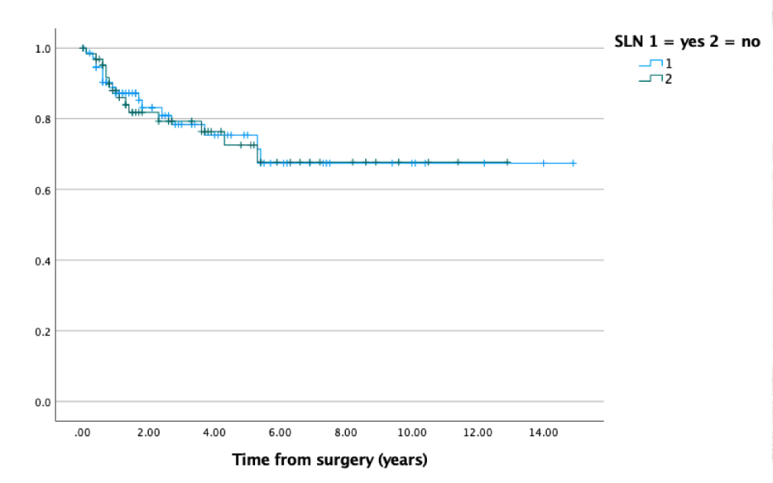
Fig. 1. Recurrence Free Survival (RFS). 31 patients were found to have recurred during follow up.
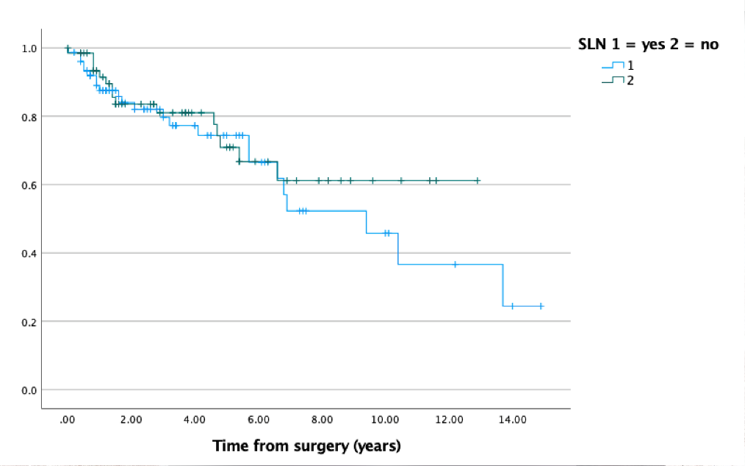
Fig. 2. Overall Survival (OS). 38 patients died during the follow up period and 22 experienced prior recurrence.

4. Discussion
This retrospective study sought to investigate the utility of intraoperative frozen sections at the time of SLND in early-stage vulvar cancer. We identified a high correspondence rate between intraoperative frozen section pathology and final pathology in SLNs. Intraoperative frozen section had a 100% positive predictive value and 98.5% (95% CI: 91.2%–99.8%) negative predictive value when compared to final pathology. Thus, no patients was incorrectly subjected to a complete IFLND subsequent to a false positive result. In addition, we found that there was no statistically significant difference in OS and RFS between those who were subjected to SLN and those who were not.
The single most important prognostic factor for vulvar cancer is the status of the lymph nodes (nodal status) [2, 3]. There is increasing interest in utilizing pre-operative imaging as a means of assessing nodal status [18, 19]. However, surgical pathology remains the gold standard method to assess nodal status. The most common method used for intraoperative evaluation of pathologic specimens is the frozen tissue section, although studies on its use in vulvar cancer have been limited. A recent meta-analysis described the use of intraoperative frozen section in 326 breast cancer patients undergoing SLN assessment [20]. The authors found a 100% positive predictive value and 83.2% negative predictive value. Brunner et al evaluated 44 patients with vulvar cancer undergoing SLND similarly found 100% positive predictive value for examination of intraoperative frozen tissue sections [21]. Three patients received false negative results and all 3 were diagnosed with micrometastasis that was identified on the pathology final report.
The SLN detection rate of 90.8% and isolated groin recurrence rate of 1.3% in this study are consistent with the established literature [6, 14, 22, 23]. Similar detection rates and recurrence profiles across studies attests to the safety of SLND in a variety of settings, including academic medical centers and community hospitals. We found no statistically significant difference in OS and RFS between those patients subjected to SLND and those who were not.
This study is limited by the lack of standardization of SLN approach and selection. Technetium-99-labeled sulfur colloid was used alone in 76 patients or in combination with blue dye in nine patients as the surgeon preferred; none of the patients examined was subjected to lymphoscintigraphy. Though blue dye was not routinely used, its addition may not have improved the detection rate. In a large series of melanoma cases, the addition of radiocolloid increased the detection rate from 87% to 99% and only one blue SLN was identified that was not radioactive [24]. Other studies also indicate that the improvement in detection rate can be attributed mostly to the use of the radiocolloid rather than the combination of dye and radiocolloid [25]. Lymphoscintigraphy might have been of use in patients with ambiguous laterality, although it is unlikely to have improved the detection rate [26]. In this study, 17 patients with a total of 26 sentinel lymph nodes failed to receive frozen section examination for no reason that was documented. Unfortunately, since this study was retrospective in nature, we are unable to determine the circumstances that warranted exclusion of frozen section examination. Since this study is retrospective, it is possible that some patients may have experienced complications that were not fully described in the patients’ medical records. Strengths include the confirmation of SLN status with immunohistochemical assessment, ultra-staging, and uniform use of radiocolloid. Immunohistochemical and ultra-staging improved chances of detecting microscopic disease that can be easily missed using standard sampling protocols, resulting in increased regional nodal failure from undertreatment [27].
Given the excellent positive predictive value for vulvar carcinoma in this study and for other solid tumors in the literature, the examination of intraoperative frozen SLN sections should be considered in the management of suspected early-stage vulvar cancer. We found that no patients were incorrectly subjected to more aggressive surgery such as complete IFLND inguinofemoral lymphadenectomy due to a false positive SLN. By correctly identifying patients who should undergo further surgery at the time of their initial SLN procedure, patients may be spared a second procedure, thereby reducing cost, potential morbidity and mortality of a second operative procedure, and potential delay in starting essential chemotherapy or radiotherapy. Integration of intraoperative frozen section analysis into the methodology of future inguinofemoral lymph node studies will further establish the utility of this approach.

5. Conclusions
In conclusion, our findings support the utility of intraoperative frozen section analysis to assess the status of the lymph nodes during initial surgery, with 100% positive predictive value and 98.5% negative predictive value.

Author Contributions
NZ—Data curation, Formal analysis, Writing–Review & Editing; JG—Data curation, Writing–Review & Editing; BW—Writing–Review & Editing; CC—Data curation, Writing–Original Draft; MR—Conceptualization, Methodology, Writing–Review & Editing; AE—Conceptualization, Methodology, Supervision, Writing–Original Draft/Review & Editing.
Ethics Approval and Consent to Participate
Not applicable.
Acknowledgment
Not applicable.
Funding
This research received no external funding.
Conflict of Interest
The authors declare no conflict of interest.

References
[1] American Cancer Society. Key Statistics for Vulvar Csncer. 2022. Avaolable at: https://www.cancer.org/cancer/vulvar-cancer/about/key-statistics.html (Accessed 18 February 2022).
[2] de Hullu JA, Hollema H, Lolkema S, Boezen M, Boonstra H, Burger MPM, et al. Vulvar carcinoma. The price of less radical surgery. Cancer. 2002; 95: 2331–2338.
[3] Keys H. Gynecologic oncology group randomized trials of combined technique therapy for vulvar cancer. Cancer. 1993; 71: 1691–1696.
[4] Woelber L, Mahner S, Voelker K, Eulenburg CZ, Gieseking F, Choschzick M, et al. Clinicopathological prognostic factors and patterns of recurrence in vulvar cancer. Anticancer Research. 2009; 29: 545–552.
[5] Oonk MH, van Hemel BM, Hollema H, de Hullu JA, Ansink AC, Vergote I, et al. Size of sentinel-node metastasis and chances of non-sentinel-node involvement and survival in early stage vulvar cancer: results from GROINSS-V, a multicentre observational study. The Lancet Oncology. 2010; 11: 646–652.
[6] Van der Zee AGJ, Oonk MH, De Hullu JA, Ansink AC, Vergote I, Verheijen RH, et al. Sentinel node dissection is safe in the treatment of early-stage vulvar cancer. Journal of Clinical Oncology. 2008; 26: 884–889.
[7] Carlson JW, Kauderer J, Hutson A, Carter J, Armer J, Lockwood S, et al. GOG 244-the lymphedema and gynecologic cancer (LEG) study: Incidence and risk factors in newly diagnosed patients. Gynecologic Oncology. 2020; 156: 467–474.
[8] Gaarenstroom KN, Kenter GG, Trimbos JB, Agous I, Amant F, Peters AAW, et al. Postoperative complications after vulvectomy and inguinofemoral lymphadenectomy using separate groin incisions. International Journal of Gynecological Cancer. 2003; 13: 522–527.
[9] Höckel M, Horn L, Einenkel J. (Laterally) extended endopelvic resection: surgical treatment of locally advanced and recurrent cancer of the uterine cervix and vagina based on ontogenetic anatomy. Gynecologic Oncology. 2012; 127: 297–302.
[10] Gemignani ML, Alektiar KM, Leitao M, Mychalczak B, Chi D, Venkatraman E, et al. Radical surgical resection and high-dose intraoperative radiation therapy (HDR-IORT) in patients with recurrent gynecologic cancers. International Journal of Radiation Oncology, Biology, Physics. 2001; 50: 687–694.
[11] Levenback CF, van der Zee AG, Rob L, Plante M, Covens A, Schneider A, et al. Sentinel lymph node biopsy in patients with gynecologic cancers Expert panel statement from the International Sentinel Node Society Meeting, February 21, 2008. Gynecologic Oncology. 2009; 114: 151–156.
[12] Brincat MR, Muscat Baron Y. Sentinel Lymph Node Biopsy in the Management of Vulvar Carcinoma: an Evidence-Based Insight. International Journal of Gynecological Cancer. 2017; 27: 1769–1773.
[13] Hassanzade M, Attaran M, Treglia G, Yousefi Z, Sadeghi R. Lymphatic mapping and sentinel node biopsy in squamous cell carcinoma of the vulva: Systematic review and meta-analysis of the literature. Gynecologic Oncology. 2013; 130: 237–245.
[14] Klapdor R, Hillemanns P, Wölber L, Jückstock J, Hilpert F, de Gregorio N, et al. Outcome after Sentinel Lymph Node Dissection in Vulvar Cancer: a Subgroup Analysis of the AGO-CaRE-1 Study. Annals of Surgical Oncology. 2017; 24: 1314–1321.
[15] Te Grootenhuis NC, van der Zee AGJ, van Doorn HC, van der Velden J, Vergote I, Zanagnolo V, et al. Sentinel nodes in vulvar cancer: Long-term follow-up of the GROningen INternational Study on Sentinel nodes in Vulvar cancer (GROINSS-V) i. Gynecologic Oncology. 2016; 140: 8–14.
[16] Oonk MHM, Slomovitz B, Baldwin P, Van Doorn H, Van Der Velden J, De Hullu J, et al. Radiotherapy instead of inguinofemoral lymphadenectomy in vulvar cancer patients with a metastatic sentinel node: results of GROINSS-V II. International Journal of Gynecologic Cancer, 2019. 29: A14.
[17] Hacker NF. Revised FIGO staging for carcinoma of the vulva. International Journal of Gynecology & Obstetrics. 2009; 105: 105–106.
[18] Garganese G, Collarino A, Fragomeni SM, Rufini V, Perotti G, Gentileschi S, et al. Groin sentinel node biopsy and 18F-FDG PET/CT-supported preoperative lymph node assessment in cN0 patients with vulvar cancer currently unfit for minimally invasive inguinal surgery: the GroSNaPET study. European Journal of Surgical Oncology. 2017; 43: 1776–1783.
[19] Garganese G, Fragomeni SM, Pasciuto T, Leombroni M, Moro F, Evangelista MT, et al. Ultrasound morphometric and cytologic preoperative assessment of inguinal lymph-node status in women with vulvar cancer: MorphoNode study. Ultrasound in Obstetrics & Gynecology. 2020; 55: 401–410.
[20] Liu L, Lang JE, Lu Y, Roe D, Hwang SE, Ewing CA, et al. Intraoperative frozen section analysis of sentinel lymph nodes in breast cancer patients: a meta-analysis and single-institution experience. Cancer. 2011; 117: 250–258.
[21] Brunner AH, Polterauer S, Tempfer C, Joura E, Reinthaller A, Horvat R, et al. The accuracy of intraoperative frozen section of the inguinal sentinel lymph node in vulvar cancer. Anticancer Research. 2008; 28: 4091–4094.
[22] Levenback CF, Ali S, Coleman RL, Gold MA, Fowler JM, Judson PL, et al. Lymphatic Mapping and Sentinel Lymph Node Biopsy in Women with Squamous Cell Carcinoma of the Vulva: a Gynecologic Oncology Group Study. Journal of Clinical Oncology. 2012; 30: 3786–3791.
[23] Broach V, Abu-Rustum NR, Sonoda Y, Brown CL, Jewell E, Gardner G, et al. Evolution and outcomes of sentinel lymph node mapping in vulvar cancer. International Journal of Gynecologic Cancer. 2020; 30: 383–386.
[24] Gershenwald JE, Tseng C, Thompson W, Mansfield PF, Lee JE, Bouvet M, et al. Improved sentinel lymph node localization in patients with primary melanoma with the use of radiolabeled colloid. Surgery. 1998; 124: 203–210.
[25] Covens A, Vella ET, Kennedy EB, Reade CJ, Jimenez W, Le T. Sentinel lymph node biopsy in vulvar cancer: Systematic review, meta-analysis and guideline recommendations. Gynecologic Oncology. 2015; 137: 351–361.
[26] Coleman RL, Ali S, Levenback CF, Gold MA, Fowler JM, Judson PL, et al. Is bilateral lymphadenectomy for midline squamous carcinoma of the vulva always necessary? An analysis from Gynecologic Oncology Group (GOG) 173. Gynecologic Oncology. 2013; 128: 155–159.
[27] Gershenwald JE, Colome MI, Lee JE, Mansfield PF, Tseng C, Lee JJ, et al. Patterns of recurrence following a negative sentinel lymph node biopsy in 243 patients with stage i or II melanoma. Journal of Clinical Oncology. 1998; 16: 2253–2260.

